# 3.1-Static Testing Basics

Chapter 3 - start at 1:00

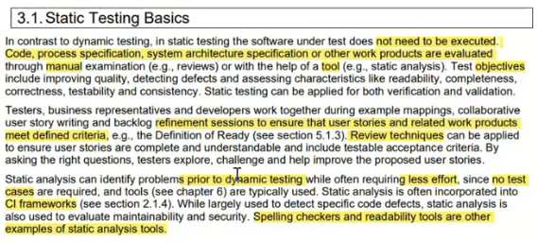

## 3.1.1-Work Products Examinable by Static Testing

Chapter 3 - start at 8:31

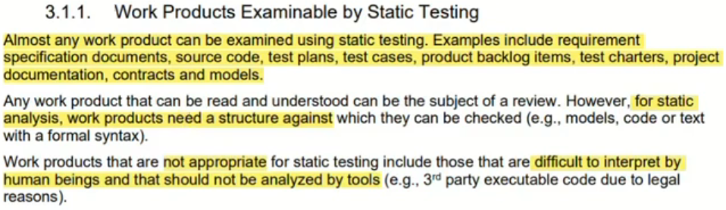

## 3.1.2-Value of Static Testing

Chapter 3 - start at 11:40

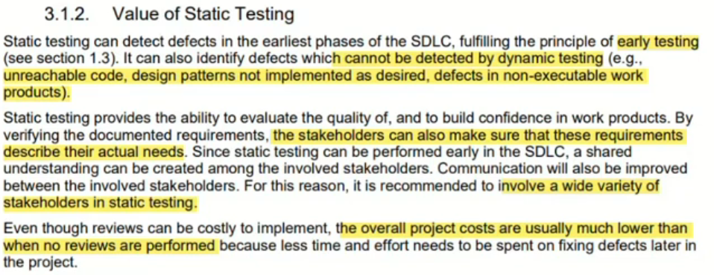



## 3.1.3-Differences between Static Testing and Dynamic Testing

Chapter 3 - start at 15:40

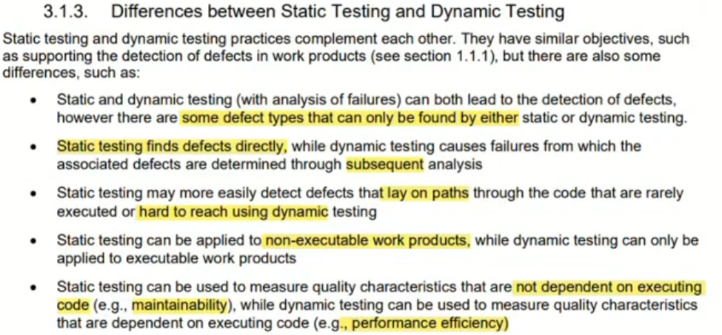

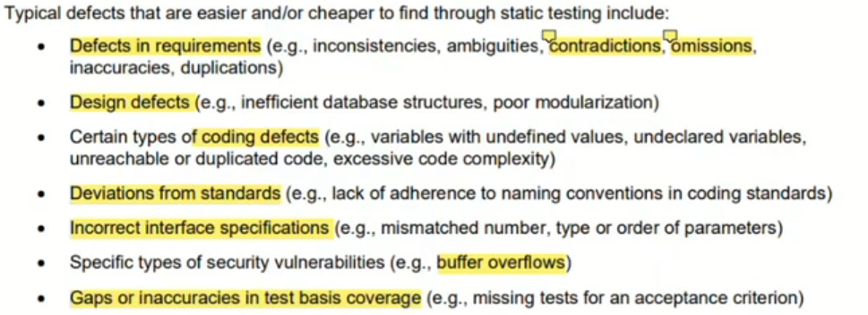

# 3.2. Feedback and Review Process

Chapter 3 - start at 25:57



## 3.2.1-Benefits of Early and Frequent Stakeholder Feedback

Chapter 3 - start at 25:57

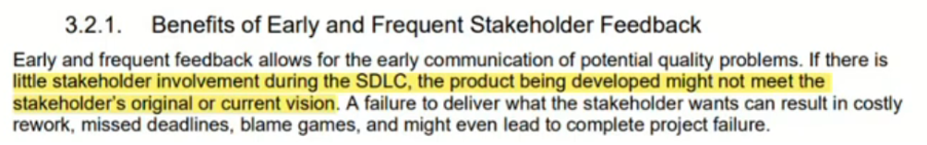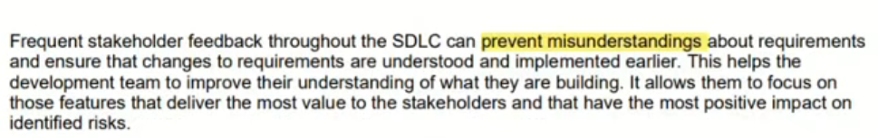

## 3.2.2-Review Process Activities

Chapter 3 - start at 27:39

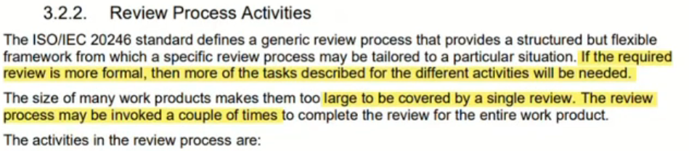

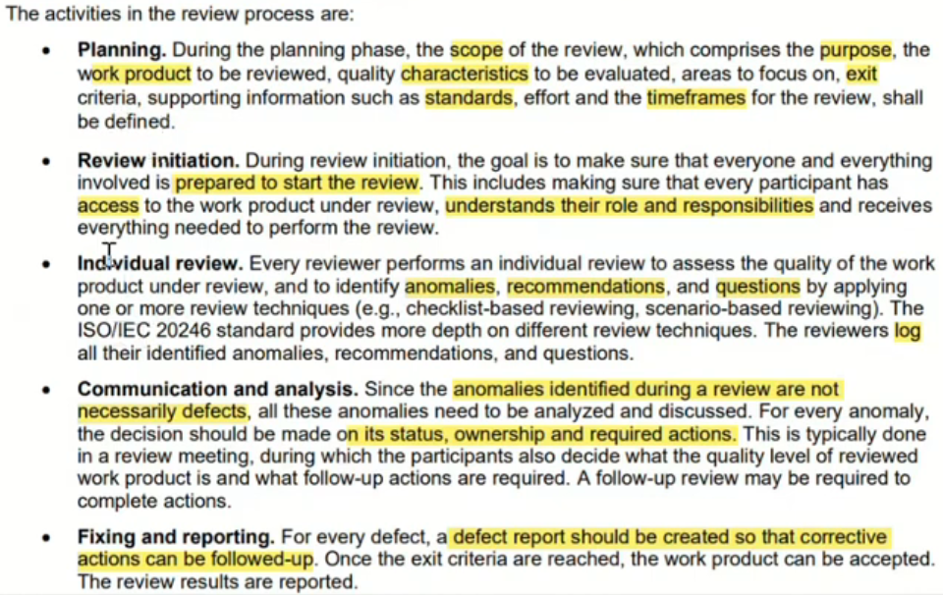

## 3.2.3-Roles and Responsibilities in Reviews

Chapter 3 - start at 32:46

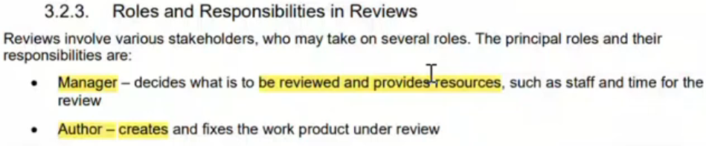

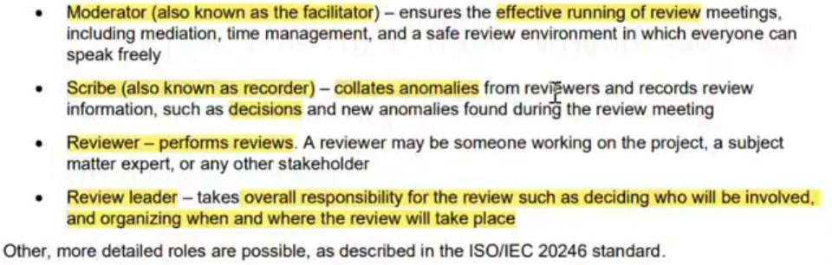

## 3.2.4-Review Types

Chapter 3 - start at 35:35

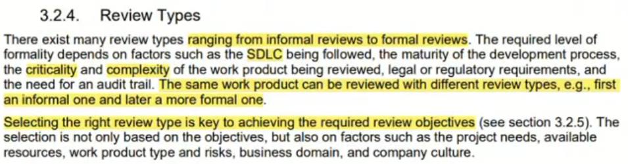

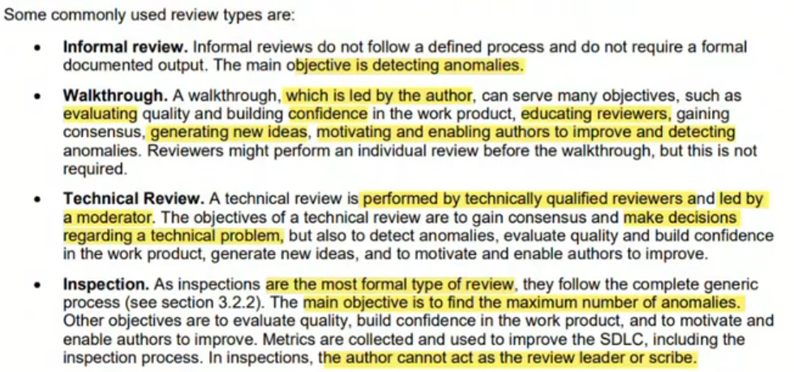

## 3.2.5-Success Factors for Reviews

Chapter 3 - start at 41:12

